Activity No. 2.1
Data Types and Arithmetic Operations
Course Code: CPE007 | Program: Computer Engineering
Course Title: Programming Logic and Design | Date Performed: August 2-7, 2025
Section: CPE11S1 | Date Submitted: August 7, 2025
Name(s): Jaime Luis M. Demain | Instructor: Engr. Jimlord Quejado
6. Output
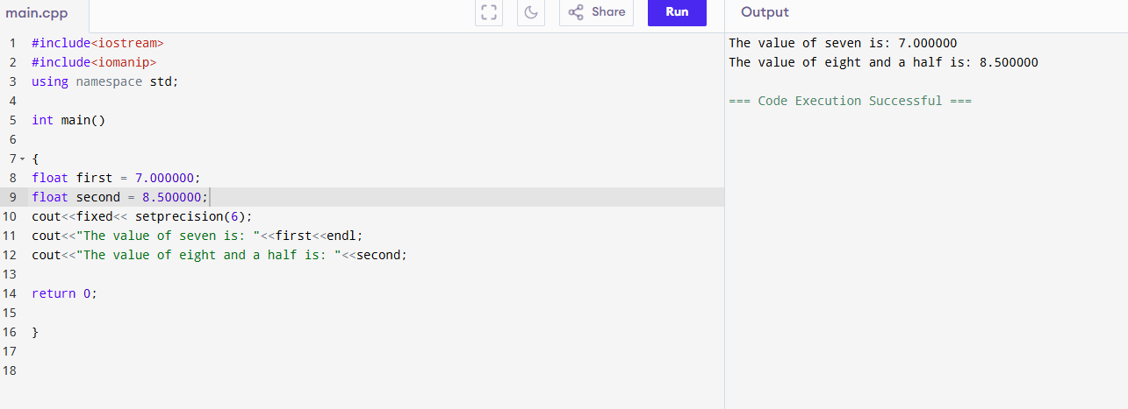
Errors: No #include<iomanip>
No cout<<fixed<< setprecision(6);
Value 7.000000 and 8.500000 aren’t declared
No declared variable in the cout line
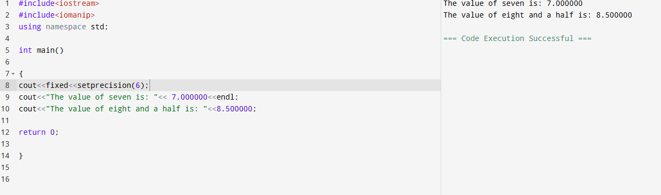
Errors: No #include<iomanip>
No cout<<fixed<< setprecision(6);
No dot on 7 0 part that will be declared as a value with decimals on cout
No endl on “cout<<"The value of seven is: "<< 7 0;” line
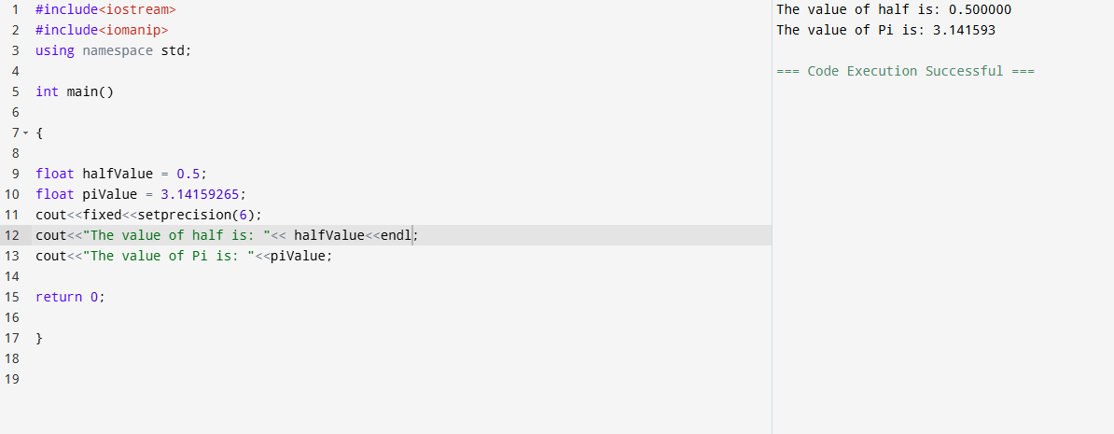
Errors: No #include<iomanip>
No cout<<fixed<< setprecision(6);
Declared variables have wrong inputs. “float halfValue = 0.6;” should be “float halfValue = 0.5;” instead and “float piValue = 3.141 592 65;” shouldn’t have any spaces.
There are wrong inputs in cout line that aren’t conformity with the declared variables like “cout<<"The value of half is: "<< half Value;” (with space) and “cout<<"The value of Pi is: "<<pi_Value;” (with underline).

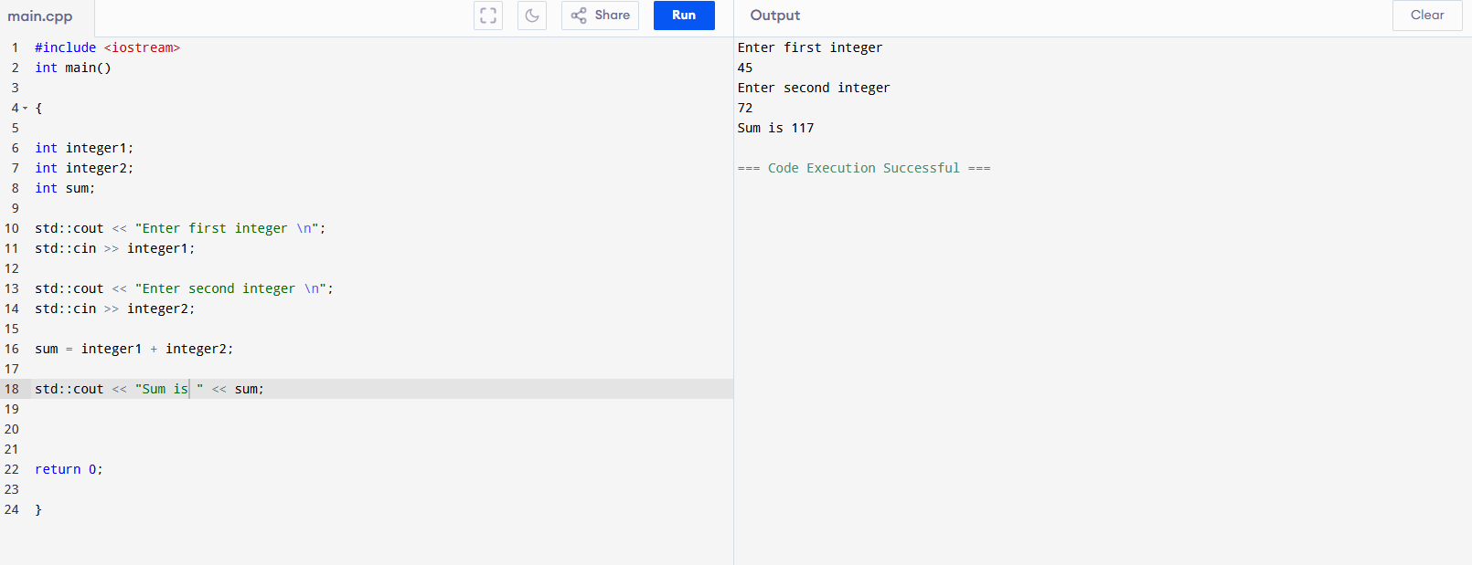
Errors: No std:: on cin and cout lines
Multiple variable declarations must be on separate lines instead of combining it in one line
Colon (:) must not be included on text that are on cout lines
Semicolon (;) has a space on first two cout lines (Enter integer part)

7. Supplementary Activity
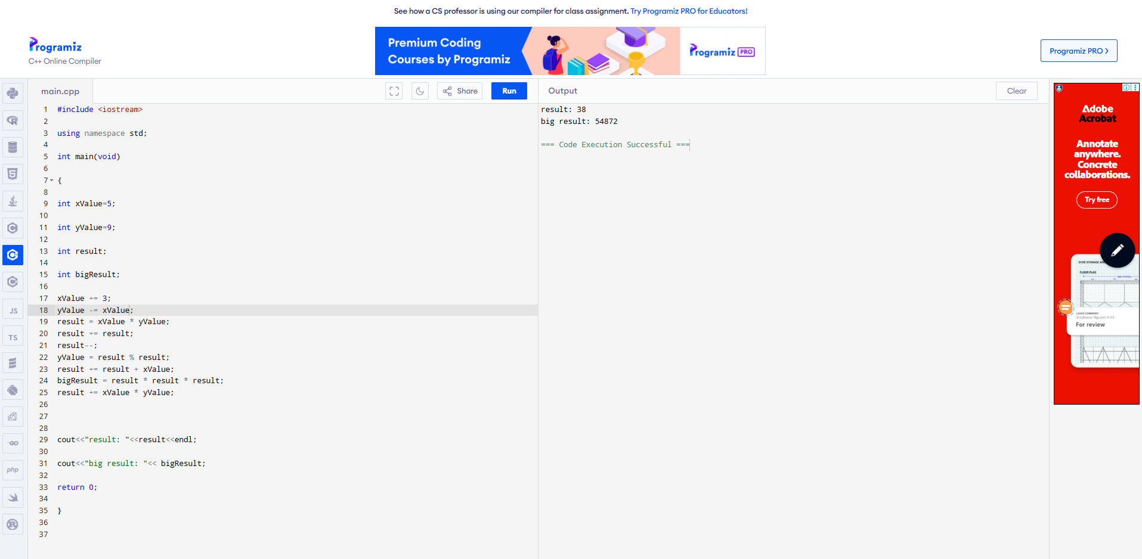
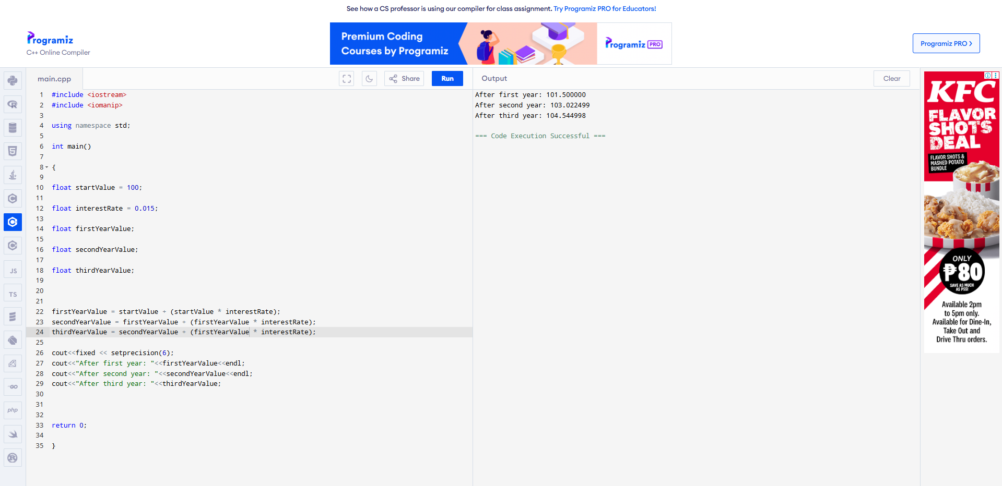
8. Conclusion
In this activity, I learned how to increment numbers and most importantly, how to output numbers in decimal form. To output numbers in decimal form, in my experience, input #include <iomanip> after #include <iostream> then input cout<<fixed<<setprecision(you input inside parenthesis on how many decimals you would to display); before the other parts of cout you would like to display with. Lastly, I learned to program a cin wherein you would input the values you would want in order to perform a mathematic expressions here in coding.
9. Assessment Rubric

